Money for Michigan:

An innovative initiative
for state-wide economic development

Proposed by

Arthur C. Brock

Targeted Currencies Network, LLC

July 11, 2004

The information in this proposal is proprietary and confidential
Table of Contents

Introduction 3
Understanding Targeted Currencies 3
Proposed Targeted Currency Projects: 4
CoolCash: Invigorating Arts & Culture while Rebuilding Troubled Urban Zones 4
Purpose 4
Overview 4
Strategic Approach 6
Flow Diagram 7
Expected Outcomes 7
Precedents for this Model 7
BusinessBucks: Stimulating the Michigan Economy with a Business to Business Currency 8
Purpose 8
Overview 8
Flow Diagram 9
Strategic Approach 10
Expected Outcomes 10
Precedents for this Model 10
Scholastic Benefits (“Bennies” or “Benjamins”): Student-Centered Initiative for Enhancing Educational Excellence 10
Purpose 10
Overview 11
Strategic Approach 12
Flow Diagram 14
Expected Outcomes 14
Precedents for this Model 15
CommunityCARES: Improving Human Welfare by Mobilizing the Under-Employed 15
Purpose 15
Strategic Approach 16
Flow Diagram 17
Expected Outcomes 17
Precedents for this Model 18
The Lakies Network: Boosting Local Economic Activity while Incenting In-State Tourism 18
Purpose 18
Overview 18
Strategic Approach 19
Expected Outcomes 20
Precedents for this Model 20
Tourist Tickets: Attracting Outside Tourism while Building Marketing Base 21
ASSIGNED TO ARTHUR 21
Purpose & Overview 21
Strategic Approach 21
Flow Diagram 21
Expected Outcomes 21
Precedents for this Model 21
Measuring the Impact of Targeted Currency Projects 21
Understanding the Costs of the Projects 21
Summary & Conclusions 22

Introduction

The Money for Michigan Initiative is a proposal for widespread economic development and increased services in arts, culture, human welfare and educational excellence during a time of shrinking state budgets to support such activities. The goals of this proposal are achieved by creating targeted currencies to unleash existing resources and make critical connections in communities where there has been an absence of traditional economic activity in US dollars.

Each of the proposed currencies targets different communities and addresses very different economic or social problems. Each currency can operate independently, although there are synergies between them that strengthen each of the projects and increase the likelihood of overall success. Careful design work has gone into each model, although they should not be viewed as finalized. It is still important to refine them with input from the respective administrative departments and the governor’s economic development goals.

Understanding Targeted Currencies

While the know-how and even the physical resources to solve most of the social and economic problems that burden our communities may exist, the problem is usually that we don’t have adequate funding to mobilize those resources and employ that know-how. That is exactly what targeted currencies do. They are designed to activate latent resources in communities to solve specific problems. They are not a panacea and should not be thought of as a replacement for normal national currencies, but they can make a vital difference in meeting people’s needs, with a minimal cash cost for the overall economic impact they produce.

There are numerous examples of targeted currencies in use. A simple, elegant and very effective one is the city of Curatiba in Brazil. The city was grappling with the health and sanitation problems posed by the shanty-towns assembled on its outskirts. The alleys and footpaths were not wide enough to accommodate garbage trucks and there was not a large enough tax-base in those areas to cover either the costs of truck-based collection, or a more labor-intensive method. The mayor implemented a brilliant solution. He placed trash collection stations at the edges of the shanty-towns and paid people for depositing trash with special tokens that were accepted for bus fares and care in health clinics. By implementing this simple token, the trash was cleaned up, the health issues were addressed and the under-employed people in the shanty-towns gained access to transportation into the city center where more jobs were available. The program was significantly cheaper to implement than traditional trash collection, yet it solved many more issues for the community.

Michigan has identified goals for economic development ….

We are proposing specifically targeted currencies for::

- Invigorating Arts & Culture in Michigan Cities
- Targeting Economic Incentives in Troubled Urban Zones
- Enhancing Education
- Improving Human Welfare Systems, Elderly Care & Child Care
- Increasing In-State Tourism
- Developing Tourism from Out-of-State
- Supporting Local Communities in “Bootstrapping” their Economies
- Enhancing Business to Business Activity within the State – within its Manufacturing Economy and in moving into the Information Age
- ??<<Improving Viability Rural Farming Communities>>

Proposed Targeted Currency Projects:

CoolCash:
Invigorating Arts & Culture while Rebuilding Troubled Urban Zones

Purpose
CoolCash was inspired by the goals of the governor’s CoolCities initiative and is specifically designed to fulfill on those goals. Transforming Michigan’s urban areas is itself a worthy challenge; add the task of altering the existing perception of our cities, especially of our youth, and this presents an even greater feat. Nothing short of establishing fresh economic and cultural activity will do the job. CoolCash does exactly that.

The state will need to clearly identify the targeted urban revitalization zones for CoolCash. Specific parts of cities such as Bay City, Midland, Saginaw, Flint, Grand Rapids, Jackson, Kalamazoo, Lansing, Muskegon, Detroit and possibly Pontiac seem like good candidates. There are other currencies in this proposal which will provide assistance to the other participating cities by stimulating business, improving local economic activity and enhancing social welfare. However, because issuing CoolCash creates a certain tax liability for the state which most of the other currencies in this proposal do not; restraint should be used in its application.

We recommend making CoolCash a limited time project, operating under the supervision of the MCACA for a five year period. At the end of the allotted period, if it proves valuable to extend it, it would be possible to continue to offer the full program or specific parts of the program, or even transition CoolCash to be a stand-alone program no longer sponsored by the state.

Overview
CoolCash is a purely electronic currency which can be exchanged by card swipe at a point of sale, by dialing into an automated phone interface, or by using a web site interface. It is a currency which is carefully issued and ultimately redeemed by the state by accepting it from individuals and business in the targeted zones as payment for state taxes.

CoolCash is issued through arts grants, managed through the existing MCACA grants programs. Instead of cutting available grants in arts and culture because of shrinking budgets, we are recommending expanding the reach of the program by giving up to 75% of each grant in CoolCash instead of US dollars.

In addition to these combined cash/CoolCash grants, a program utilizing the Fast Track Land Act for allocating abandoned houses and properties in the targeted zones as studios, galleries or residences for artists and artisans, and for key cultural applications such as performing arts theatres, museums or possibly restaurant/coffeehouses (offering small venues for local musical performance and art exhibition). Payment for a discounted market-value for the properties allocated to individuals and commercial endeavors could be accepted in CoolCash and US dollars for transfer of title. Minimal payment may be required from non-profit arts and cultural organizations.

The combination of the arts grants and housing is a key to attracting the arts and cultural activity into these zones and initiating the beginnings of a local renaissance. It is necessary to transform these neighborhoods from fertile ground for squatters, crack houses and other public safety concerns to a rewarding setting for families, businesses and individuals spending leisure time. It has been demonstrated in numerous urban areas, that artists moving into a neighborhood sets in motion a rebirth process as they fix up their personal environment and create and attract businesses with unique cultural appeal.

The value of CoolCash is backed by the state’s promise to accept it as payment for taxes from individuals and businesses in the targeted development zones. If the zones are selected properly, this presents very little financial risk. There is already very little tax revenue being collected in these neighborhoods – most of the businesses closed; many of the houses are abandoned. For a limited time, the state creates an incentive for businesses and individuals to build their businesses and community and helps fuel the process by issuing a currency to prime the pump of economic activity. If properly deployed, there should be healthy economic activity to create a tax base once CoolCash is no longer being accepted as tax payment. However, for the duration of the project, CoolCash should be accepted for any type of state tax payment inside those zones (such as sales tax, income tax or property tax).

Tax payments are a nice incentive, but we are really trying to build currents of new economic activity, not simply have people immediately send CoolCash back to the state for taxes. Some additional incentives are necessary for entrepreneurs and businesses to enter these zones and find it attractive to accept CoolCash as payment from the artists. An ideal additional incentive is utility payments.

It is much more attractive for businesses to become CoolCash participants if they can pay up to 50% of their utility bills in CoolCash. Since delivery of utility service is clearly associated with the address where the service is connected, it is easy to ensure that this benefit is limited to addresses in the targeted zones.

How could this be appealing to the utilities? They could limit acceptance of CoolCash to no more than 50% payment of the bill for on-time payments only. The payment can be made through a web interface which also collects the electronic payment information for the cash portion of the payment. This ensures that CoolCash payments are always received with their US dollar counter-parts for full and timely bill payment. Then the utility companies can then choose to spend the CoolCash they receive on products and services from the target zones, philanthropic giving to NPOs or for state tax payments.

As a critical mass of businesses assemble in these zones, it even becomes feasible for businesses to pay employees in part with CoolCash. This sets the foundation for ongoing economic activity and growth.

We can amplify the economic activity further through the application of a “hoarding tax” on CoolCash. This is called demurrage, and it creates a “hot potato” effect increasing the circulation velocity of the currency. At the end of each month, a 1% charge is deducted from each account with a non-zero balance. This functions as a kind of negative interest to increase spending and economic flow instead of hoarding and storing value in the currency. (See important examples of success cases such as the Worgl in Austria to illustrate this effect.) The fees collected by demurrage can be used to help fund the operation of the network or for additional non-profit activities in these zones.

Strategic Approach
CoolCash creates a magnetic pull between the artists and artisans that will be the true agents of transformation in the depressed zones which are targeted for renewal. It not only provides the motivation and resources for this renewal, but also stimulates economic activity in those zones giving rise to new businesses, stores and restaurants in zones where these are conspicuously absent. Businesses will be attracted to these zones by the prospect of being able to pay taxes, utilities and partial payroll in CoolCash. They will cater to the taste of the artists wielding this money. Unique and tasteful local shops will emerge to fulfill this need. This incentive model makes it possible to foster the growth of new “cool zones” which have been demonstrably successful in areas such as Royal Oak and Ferndale. Building a healthy economy while creating a cultural renaissance establishes a solid tax base for the state in areas where the civic costs for welfare programs and public safety likely outweigh tax revenue.

Artists have an eye for “cool.” They also actively create it in their environment. Yet they frequently lack the financial means and economic influence to shape their communities. CoolCash give them this leverage. Instead of the state trying to “plan cool” by overseeing the development of communities and businesses, the artists naturally manage that process by being given the means to exert their influence. CoolCash is a novel approach to giving the artists buying power without it costing the state in national currency.

Planning and promotion will be critical factors in the success of this project. Artists and entrepreneurs will need to see that there is a plan which makes it appealing to relocate into these zones. Moving a few individuals will not make the necessary difference or create adequate economic activity. Numerous individuals must be slated to move into an area with sufficient density to influence the cultural and economic activity in the neighborhood.

Flow Diagram
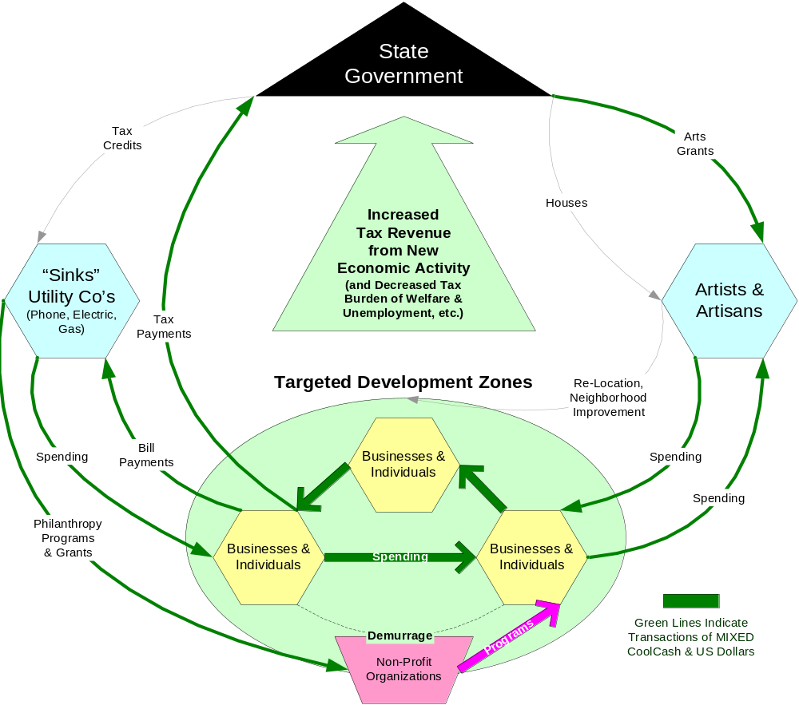

Expected Outcomes
Direct-
Secondary-

Precedents for this Model
There are precedents for certain aspects of this model, but CoolCash is actually a quite unique design geared specifically to mobilize resources to solve the problems identified in the Cool Cities project. It has the elements of unique issuance by location found in the Curitiba Trash Tokens. It employs demurrage to increase economic activity as seen in scores of successful currencies such as the Worgl Shilling. It is backed by the state by cash-equivalency for tax payment like previous state-sponsored economic development initiatives and tax-credits.

BusinessBucks:
Stimulating the Michigan Economy with a Business to Business Currency

Purpose
The purpose of a general business to business currency is to encourage exchange across the state, to allow local businesses to compete with out-of-state or national firms, and to provide an economic system that is counter-cyclical to the $US based economy.

In particular, given the State’s dependency upon the manufacturing and automobile sectors, a targeted currency can enable smaller local businesses to compete with larger or national businesses. Further, such a currency can also promote the transfer of jobs from manufacturing to the information age.

Overview
A business to business currency, BusinessBucks, can be established as an electronic currency that is issued by the participants in a transaction in the form of a simultaneous debit and credit. This is known as a mutual credit exchange system, similar to a Local Exchange Trading System (LETS). At the time of each transaction, the seller of goods is credited with Business Bucks and the buyer debited. An agreement is signed by each member of the network to accept Business Bucks as payment for their goods and services to at least offset the value of the goods/services they have received. This type of system enables the trading of goods and services among local business members, as well as among those individuals employed by such businesses.

Auto companies, and other manufacturers, can agree to accept contracts/bids with BusinessBucks members in $US and BusinessBucks – enabling such member firm to compete more favorably with larger or out-of-state firms by offering a competitive or lower cost US$ bid to the auto companies, supplemented by Business Bucks. The BusinessBucks receipts can be used to pay workers supplemental salaries. The auto companies, and other manufacturers, in turn can accept partial payments for product by Business Bucks members, and may also pay their workers supplemental Business Bucks.

An example of this system is the very successful Swiss WIR system. In Switzerland, the WIR accounts for 25% of business transactions and is attributed to be the stabilizing factor in the economy. It introduces another feature which is the ability for members to borrow in the new currency. In order to facilitate this feature a financial institution, or credit union, needs to act as an intermediary. This could exist in either of two forms. The more traditional approach is for that institution to provide lower cost BusinessBucks loans to small and local businesses against collateral, that may be used to pay other members or their workers in BusinessBucks. Deposits of BusinessBucks may be re-deposited in the system, at a zero rate of interest. A more progressive approach would be for the credit union to act as a credit rating and collateral holding institution, authorizing credit lines for a fee and collateral, but allowing the issuance of the currency to occur between the two parties directly. Only in the event of default would collateral be used to secure a negative balance in the system.

The advantage of such a borrowing facility is that loans may be made a rate of interest below that of the $US system providing a positive growth incentive to members, while any surplus of Business Bucks will not earn interest, discouraging hoarding. Both these aspects contribute to the counter-cyclical nature of Business Bucks relative to the US and Michigan economy.

A further feature to the system can be the inclusion of Universities and other educational institutions in accepting partial tuition payments in BusinessBucks for Information Age courses. Given the marginal $US cost of additional students this represents a positive source of $US cash flow for the institutions as well as promoting a move away from manufacturing dependency towards more information age jobs.

The Government may also be able to offer some of its services in BusinessBucks, the credits of which can be used to incent other targeted groups, support the establishment of the credit union, and potentially pay supplemental salaries/wages to targeted workers.

Flow Diagram

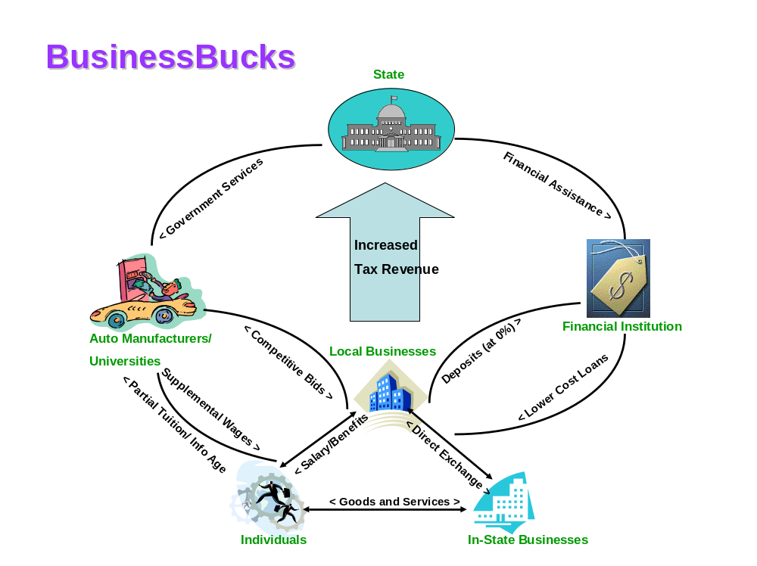

Strategic Approach

Expected Outcomes
Primary goals:
Increased economic flow within local businesses
Increased or stable employment
Supplemental earnings for individual workers
Encouraging more competitive bids by local businesses – lowering the $US cost of manufacturers, offset with BusinessBucks
Stimulating Information Age educational opportunites

Secondary Goals:
Exchange between the various targeted currencies within the State

Precedents for this Model
LETS systems, and the Swiss WIR
WIR in Switzerland
LETS systems
Reciprocal Trade & Barter Networks

Scholastic Benefits (“Bennies” or “Benjamins”):
Student-Centered Initiative for Enhancing Educational Excellence

Purpose
There is no better way to gain a thorough understanding of course material than to teach it to another, and the earlier students practice the habit of giving back to their communities the more they will incorporate the behaviors into the rest of their lives.

If you empower students in a creative way to become participants in one another’s learning, you can build community, promote educational excellence, and give them the early relationship to learning that it is a relevant and engaging part of their life experience.

The purpose of this initiative is to improve the quality of Michigan education, without imposing an undue financial burden on local school districts. We will provide incentives for primary and secondary level students to actively support the educational needs of the younger students who follow them.

By drawing the older students into tutoring and mentoring relationships with younger students, we can simultaneously enrich the opportunities for scholastic achievement for the students who need help, and deepen the involvement and understanding of the students who teach.

Overview
In co-operation with participating school districts and state universities, the State of Michigan will establish a school issued Scholastic Benefits currency called 'Benjamins.’ This electronic currency will be credited to students for the hours they spend tutoring other students, either in the schools or in a setting that otherwise enables accurate reporting of hours of input.

The primary redemption of the currency shall be in the form of an accumulating tuition credit that can be redeemed through participating Michigan colleges and universities. This credit will represent half (.5) of the total Benjamins accrued to the student’s account, and will not be available to them directly except for the purposes of tuition credit at the time of matriculation.

Half of the remainder (.25) will be allocated by the student to provide for the school community. For this portion, school administrations will determine a selection of priorities that they feel are equally acceptable and valid areas for funding. This may take the form of extracurricular organizations, portions of arts or sports programs, or anywhere they feel that there is some level of discretion in budgeting. Holders of Benjamins are then able use their currency to direct that amount of funding into the alternative that they wish to support. These credits will serve as ‘votes’ on the spending of existing school funds, and will not represent any absolute investment on behalf of the State.

The remaining portion (.25) of the Benjamins is the students to spend. This provides an immediate reward for their good work. In communities that utilize the CommunityCARES, Lakies tourism currency, or the CoolCash arts currency, Benjamins can be exchanged to provide students with access to the goods and services available within those systems. In communities not participating with the other programs, area businesses can be enrolled to accept a portion of the cost of goods in the form of Benjamins. This allows businesses to support education, while at the same time bolstering their bottom line by attracting customers who will be paying for part of their purchase in US currency.

Students who receive tutoring shall have the means to provide feedback about their experience by rating the quality of the instruction. These ratings will be available to future students and their parents who may be looking for a tutor with a good reputation. These ratings will serve as a score board to show who are the top performers system wide, and will be a source of pride for some students who may not have other opportunities to be appreciated for their strengths. It is also possible that consistently strong performers could be granted some form of bonus, but it is our experience that the simple presence of a reputation system encourages people to strive for higher placement.

Students who receive tutoring in the program will be eligible for bonuses if they in turn provide tutoring to the next group of students down the chain. The ultimate focus of the program will be to encourage students to see themselves as part of a chain of knowledge. To learn, and then to teach what you have learned, is the calling we wish to inculcate into as many young Michiganders as possible.

Strategic Approach
There are three broad constituencies we have considered; the needs and resources of the State and communities of Michigan, the ends and interests of the educational system on the primary, secondary, and collegiate levels, and the welfare and growth of the student citizens. Each aspect of our program is designed to integrate and serve all of these sectors by drawing the students into greater involvement with the system, give them a sense of ownership and accomplishment, and align their interests with the school’s and those of the greater community.

The path to success begins when students, who may have never before seen themselves as having the intellectual or financial means to aspire to a college degree come to know themselves as people with futures of great possibility. This program will not just be something that will touch their lives in a distant future, but will be felt every day as they envision themselves as capable and contributing members of a larger community; a community that offers reasonable hope of advancement through effort. And it is important to underscore that this advancement will require true effort. It will not be a process that simply hands a future to them, but it will engage them in earning their futures for themselves. They will not be subsidized. They will be contributors.

Our choice of contributions to reward was not merely one of public service, but of a service that would most directly impact their own learning and relationship to education. Certainly, it will benefit the schools to have the students carry some of the burden of instruction, and thus free adult instructors to put their expertise to more focused use, but consider also how this will impact the outlook of the students involved. By enrolling them in the education of another, they will better appreciate and understand the role of the educator as well as their own role as a student. A teacher will not just be another random authority, or a classroom just another room to distract oneself within. They will see the purposes and meanings that you can only see from the other side of the desk.

They will earn through giving of themselves, and will reap the pride of the acknowledgement of their gifts. They will be able to get value from giving value, and the value they receive will itself encourage certain behaviors. When they have some voice in allocation of some discretionary funds from the school budget, even if it is only a nominal amount, it will begin to instill in them a sense of ownership and responsibility for the school. Facilities that were earned and chosen by their own efforts are much less likely to be facilities that are neglected or abused. Programs that they championed are programs that they will work to make successful. And they will not only have the experience of choice, but the experience of having generated the availability of choice and providing for their community.

They will, of course, get the satisfaction of providing for themselves in a direct and immediate way by earning the portion that is theirs to spend at local businesses. This is a great opportunity for the businesses to support education while at the same time bolstering their bottom line by attracting customers who will be paying for part of their currency in U.S. currency. In communities that utilize other targeted currencies, the liquidity and memberships of those currencies can be enhanced by the expansion of their bases to include the students and businesses who are introduced to them through the conversion of Benjamins.

At the very end of the process, the deepest benefits will be felt by the State, as a new generation of students enter the collegiate system with greater commitment to their communities, more practice at citizenship, and a deeper and more profound relationship to the learning process. Each of the students they have taught and mentored will have an incentive to continue the process onward, and a culture of service and learning will emerge in their minds as just the natural way things always have been.

Flow Diagram





< Ben$ for goods
Older Students
Younger Students
State
Local Businesses
College or University
Ben$ for tuition >
School Funding
Knowledge
Schools
Ben$ for programs
Feedback ratings
Knowledge
Tuition Assistance >

Expected Outcomes
Primary Outcomes
- Tutored students will show improved grades, test scores and performance on course work.
- Students providing tutoring will attain a deeper understanding of the learning process and of the material they teach.
- Students most prepared to take advantage of the opportunities provided by higher education, and most likely to repay the value back into their communities, will have a mechanism by which to earn tuition relief. They will then more likely to continue their education and reach their potential.

Secondary Outcomes
- Increased voice in resource distribution will increase student involvement in the schools and their learning experience, and cast them into a more committed role of showing proper stewardship over those resources.
- Peripheral workloads of teachers will be reduced by students more actively helping one another. This will free the teachers to focus where they are most needed.
- Greater association across age boundaries will foster a stronger school-wide community and decrease negative schoolyard behavior such as bullying.
- Increased responsibility and ownership will reduce vandalism and graffiti.

Precedents for this Model
Several cities have successfully applied currencies to facilitate incentive programs. When the Time Dollar Institute of Washington, D.C. used a modified Time Dollar implementation in the Chicago schools, they were able to harness the genius and energy of students to tutor one another and provided rewards that were designed to help students cross the digital divide. One of the pleasant side effects was a marked shift in behavioral patterns. Students were not only less violent toward the students they taught, but they also became the advocates of their charges, making sure that none of their peers degraded the atmosphere for learning of ‘their’ students.

Christian Isquierdo, associated now with the Community Hero Card and the Pilot City Health Program in Minneapolis, was able to achieve dramatic success in San Juan with his Bank Left school incentive system. He demonstrated not only that the participation and attendance of students could be improved through the introduction of a targeted currency, but also the willingness of local businesses to support and participate in initiatives of this sort.

There are many other examples, both within and outside of the domain of currency that provide evidence that increased student involvement is a vital ingredient in assuring academic success.

The US Department of Education visiting this subject in their publication, “Educational Reforms and Students at Risk: A Review of the Current State of the Art” Rossi, et al., stated:

Researchers increasingly conceptualize poor educational performance as the outcome of a process of disengagement that may begin as early as a child's entry into school (Finn, 1989; Kelly, 1989; Merchant, 1987; Rumberger, 1987; Natriello, 1984). According to this model, students who do not identify, participate, and succeed in school activities become increasingly at risk of academic failure and dropout. In order to improve student achievement and persistence, the model suggests that the school climate must foster "investment" behavior -- schools must encourage student involvement in academic and extracurricular activities by stimulating their interest, increasing their personal resources (e.g., remediating skill deficiencies), and rewarding their efforts.

Our proposal integrates the best of these prior programs and research into a manageable next step for the Michigan school system.

CommunityCARES:
Improving Human Welfare by Mobilizing the Under-Employed

Purpose
CommunityCARES (Cooperative Action Resource Expansion System) is designed to mobilize the human resources within communities to the benefit of individual members and the community as a whole. The CommunityCARES program specifically targets those most wealthy in a time currency system - the underemployed.

Overview

CARES are specifically designed to help those faced with underemployment, including the unemployed, partially employed, stay at home parents, disabled adults, the elderly, adults who are continuing their education, and retired or semi-retired persons.

Participants earn CARES for each hour spent providing care or service to another member. This can range from professional services such as handyman work to personal care, preparing meals or running errands. CARES help expand people’s resources by facilitating the exchange of time and skills among the members of a community.

For example, a young man earns CARES by painting the house of a retired neighbor who does not have enough cash to hire painters. The young man redeems his CARES to receive tutoring from a professor who is also a member of the system. The professor can either exchange her CARES for delicious, home cooked meals, or use them to pay for quality assistance for her disabled child who lives in another town.

CommunityCARES are an electronic currency – transactions of CARES can be managed via a web interface or automated phone system. Members will search available resources by keyword, category (similar to yellow pages) and by distance radius. Initial contact between participants will be primarily through a web site, although there may also be dedicated CARE Finders and matchmakers who can assist with this process.

Matchmakers are volunteers from the network itself who will assist in general matching of needs with resources for those members with limited Internet access or experience. CARE Finders go beyond matchmakers by assisting those with special needs such as the disabled or elderly who need more dedicated care.

Another important aspect of the technology is a built in reputation system. Typically, people rely on recommendations and referrals from trusted friends and family for things like babysitters and numerous household services. Members establish a reputation on the CommunityCARES system by getting ratings from people they have served who can vouch for their work. These ratings will be viewed by others on the system, similar to eBay seller and buyer ratings. This function helps fosters trust among its members.

Strategic Approach
The state will sponsor the infrastructure for operating a CommunityCARES network to communities that qualify through creating initial grass roots participation. Communities qualify by having at least thirty participants pre-registered, a five person leadership team and a volunteer matchmaker. The goal is to encourage healthy community participation between 100 and 1,000 active members in each exchange network.

CommunityCARES will need to be promoted to the underemployed for them to discover the opportunity to participate. Promotion of the benefits and opportunities of the program could include posting notices in key locations like unemployment offices, temp services, employment agencies, social security and welfare offices, adult education facilities, senior citizen centers, fraternal lodges, VA centers and hospitals, retirement and nursing homes, local access cable channels, city services web sites, and employment newspapers or classified sections.

A key success factor for CommunityCARES is to address needs specific to the underemployed such as adult education, job retraining and employment assistance. The first step is enjoining the partnership of local community colleges and at least one correspondence school or distance learning program in the state to accept CARES toward their tuition. This provides clear value to members of the exchanges such that they know they have something worthwhile to spend their CARES.

Flow Diagram

Expected Outcomes
Primary Outcomes
- The underemployed receive services in the domain of human welfare, even though they may not have the normal financial means to purchase them.
- The underemployed experience greater worth by contributing and providing value to their communities.
- Special needs populations gain greater access to quality services that are not adequately available through traditional assistance programs.
- All participants are acknowledged and compensated for their unique skills and talents.

Secondary Outcomes
- Studies show that members experience higher quality of service and care through time exchange programs than they do from the traditional, overworked care providers.
- The exchange of valuable human services strengthens community.
- Communities have an impact in the needs of specific groups which are often underfunded and overlooked, such as the elderly, children, and disabled.

Precedents for this Model
There are several examples of time-based currency models available, and they are perhaps the most popular kind of targeted currency in use today.

Time Dollars were originally created in 1986 to specifically target those living in nursing homes. Since then, it has spread to over 300 programs in 30 states across the US. (and programs in Canada and the UK) The basic premise is the same: members of a community exchange their time, skills, and services for the time of others. Time Dollars have been successfully applied to address the areas of healthcare, youth crime, and peer-to-peer tutoring.

Another elegant example of what time-based currencies can accomplish is found in Japan’s Hureai Kippu programs. There are currently 372 regional “Caring Relationship Tickets” programs sponsored by the Japanese government to address Japan’s boom in elderly population. In this system, participants earn credits for each hour spent helping an elderly person. These credits can be given away, saved until future use, and in some areas, can be transferred to the volunteer’s friends or family in another city.

The most impressive result of the Hureai Kippu has been the reported preference of the elderly to receive their care through volunteers of the system. Not only are their health care costs significantly reduced, but they prefer being assisted by fellow community members rather than the busy professional care givers.

Both examples demonstrate that time-based currency systems provide the opportunity for participants to get the things they need without spending cash.

The Lakies Network:
Boosting Local Economic Activity while Incenting In-State Tourism

Purpose
The Lakies project will help people living in tourism-based towns support each other in a stronger community by creating a currency based in sufficiency. It is designed to accelerate economic flow within the community, placing more emphasis on exchange and discouraging the hoarding of money.

Secondarily, it will provide an incentive for in-state tourism (income) and for in-state procurement (expense) that will increase economic flow to and from sectors within the state that were previously not a significant part of the economic circle of these towns and conversely minimize the amount of revenue that is leaking out of the state and country. .

Overview
Lakies will be issued in an electronic mutual credit system, where each transaction creates the positive and negative account balance appropriately for the buyer and seller. Transactions can happen via a swipe card, or over a telephone or the Internet.

Both individuals and merchants will have accounts, and everyone will be eligible to issue their own negative balance (debt to the system) within their credit limit. Credit limits will be dynamically created, based on the account holder’s previous transaction history. The higher their economic activity and the more value they produce for the community, the larger a negative balance they can carry. People and merchants who have less economic activity and produce less for the community will be allowed to owe the system less, giving them a smaller credit line.

The system will feature a ‘hoarding tax’. This tax, charged at 1% of the positive balance, will create an incentive for people to spend their money each month, increasing the velocity of exchange. The money will be collected by the central authority, and will be used first for the administration costs of running the system. Once that minimal cost is met, the rest of the funds can be used to support community-based projects, which will ultimately be chosen by the community. The fund could traditional marketing activities like a local business flyer in hotel rooms, community beautification or housing support that emphasizes home ownership for local laborers.

Merchants, restaurants and possibly even land lords will accept Lakies as partial payment for goods and services. Some businesses with high cost of goods may choose to take only 25% of payment in Lakies, while other businesses, like land lords, could take a majority of their fees in Lakies.

Employers would pay their employees in a mix of Lakies and $US, lowering the burden of competition for US dollars, which are issues in a paradigm of scarcity.

By accepting CoolCash, and BusinessBucks in a 1:1 exchange for Lakies, a new market becomes open to in-state tourism. While participants in these systems might not have been able to afford a vacation, or, conversely, would have left the state for a vacation, the ability to exchange these currencies for Lakies will be an incentive to support regional tourism. Additionally, participants in The Lakies Network will have an incentive to keep more of their business sourcing within the state, providing new business opportunities in the more industrial areas, and creating a stronger state-wide economy.

The system would have increased value if the state were to accept some percentage of sales taxes in Lakies, thereby lowering the US dollar needs of the local businesses. The state can then spend the Lakies on in-state procurement, creating an improved incentive for state funds to be spent at local businesses.

Strategic Approach
Each community will create a membership organization that owns the network. Members are local businesses, artisans and others who will take Lakies in total or partial payment for services.

The Lakies transaction network will be supported by a local bank or credit union that will manage transaction clearing, hold the ‘hoarding tax’ account and clear transfers in and out of the other Michigan-based currencies. The benefit to this bank will be an increase in local merchant and checking accounts, as has been documented in Ithaca, NY. The benefit to the community is that they retain a higher percentage of the economic activity by a locally-owned bank. Less debt-based interest will leak out of the community to the financial centers in Chicago, New York and San Fransisco.

Since this will be a community-by-community effort, each system will need to have significant grass-roots support to succeed. Our research and insight suggest that currencies without local genesis will have much less impact than one that is created by a communal realization that new economic tools are needed.

When the community takes responsibility for creating economic flows that strengthen their community, spirit and engagement will increase. This will provide not only a higher quality of life for members of the community, but a better sense of linkage with other communities in the state that are taking on similar initiatives. Opportunities to expand these offerings to education and health care can grow out of the initial step of improving local exchange.

Individual
Local Biz
Community Fund
demurrage
Tourist
Credit Union

Expected Outcomes
Primary goals include:
- increasing economic flow within existing economic exchange
- increasing employment
- increasing US dollar flow into the community
- reducing US dollar outflow from the community

Secondary goals include:
- reducing discounting, encouraging full-price (mixed currency) transactions
- greater reliance on regional businesses and strengthening of exchange that transcends individual communities
- increased reliance on local produce by encompassing regional farmers and state-developed goods by exchanging Lakies into other currencies.

Precedents for this Model
Examples: Toronto Dollars, Ithaca Hours, LETS (70+ in New Zealand, 200+ in Australia)

Tourist Tickets:
Attracting Outside Tourism while Building Marketing Base

ASSIGNED TO ARTHUR

Purpose & Overview

Strategic Approach

Flow Diagram

Expected Outcomes

Precedents for this Model

Measuring the Impact of Targeted Currency Projects
One of the unique advantages to a well-designed targeted currency is that it is possible to precisely track and measure all of its economic activity. If the currency is set up to have centralized clearing of the transactions, the levels of economic activity are clearly recorded. In fact, ongoing analysis can be done to tune the behavior of a currency to help it reach pockets of inactivity or increase appeal early-adopters.

An economic impact index should be created for each project which identifies the expected economic activity produced for each dollar invested in the project. This metric can actually be measured and adjusted as the project progresses. For some of the currencies, it should be feasible to have each US dollar invested create $50 to $500 of economic activity on the network. This effect significantly increases as more members of each community adopt the currency into their normal business activities. Consider that less than 1% of the business activity charged on credit cart networks (VISA, MC, etc) goes to cover costs of the network. Getting the equivalent of one hundred dollars of economic activity for each US dollar invested in targeted currency infrastructure is a suitable goal.

Understanding the Costs of the Projects
In order for each currency project to succeed, there will need to be some investment in:
- Systems Design & Strategic Planning
- Promotion & Education about the Currency
- Network Infrastructure for Managing Currency & Transactions
- Project Administration & Oversight
- Impact Analysis & Publicizing of Results

Summary & Conclusions
Application of targeted currencies may be a novel and unusual tactic for a State government, but accomplishing the goals of the CoolCities project and turning around Michigan’s economy calls for exactly this kind of innovation. Real change will not come from doing the same things we’ve tried in the past which have failed us.

The key to stimulating economic growth is activating the flow of latent resources in our communities. Careful application of systems of currencies, incentives and rewards accomplishes that very task without requiring large investment of dollars. Local currencies give people and communities the means to help themselves, a way to “bootstrap” their economic development and reach healthy levels of activity.

It is the people who will build Cool Cities. Let’s give them the tools to get started.

